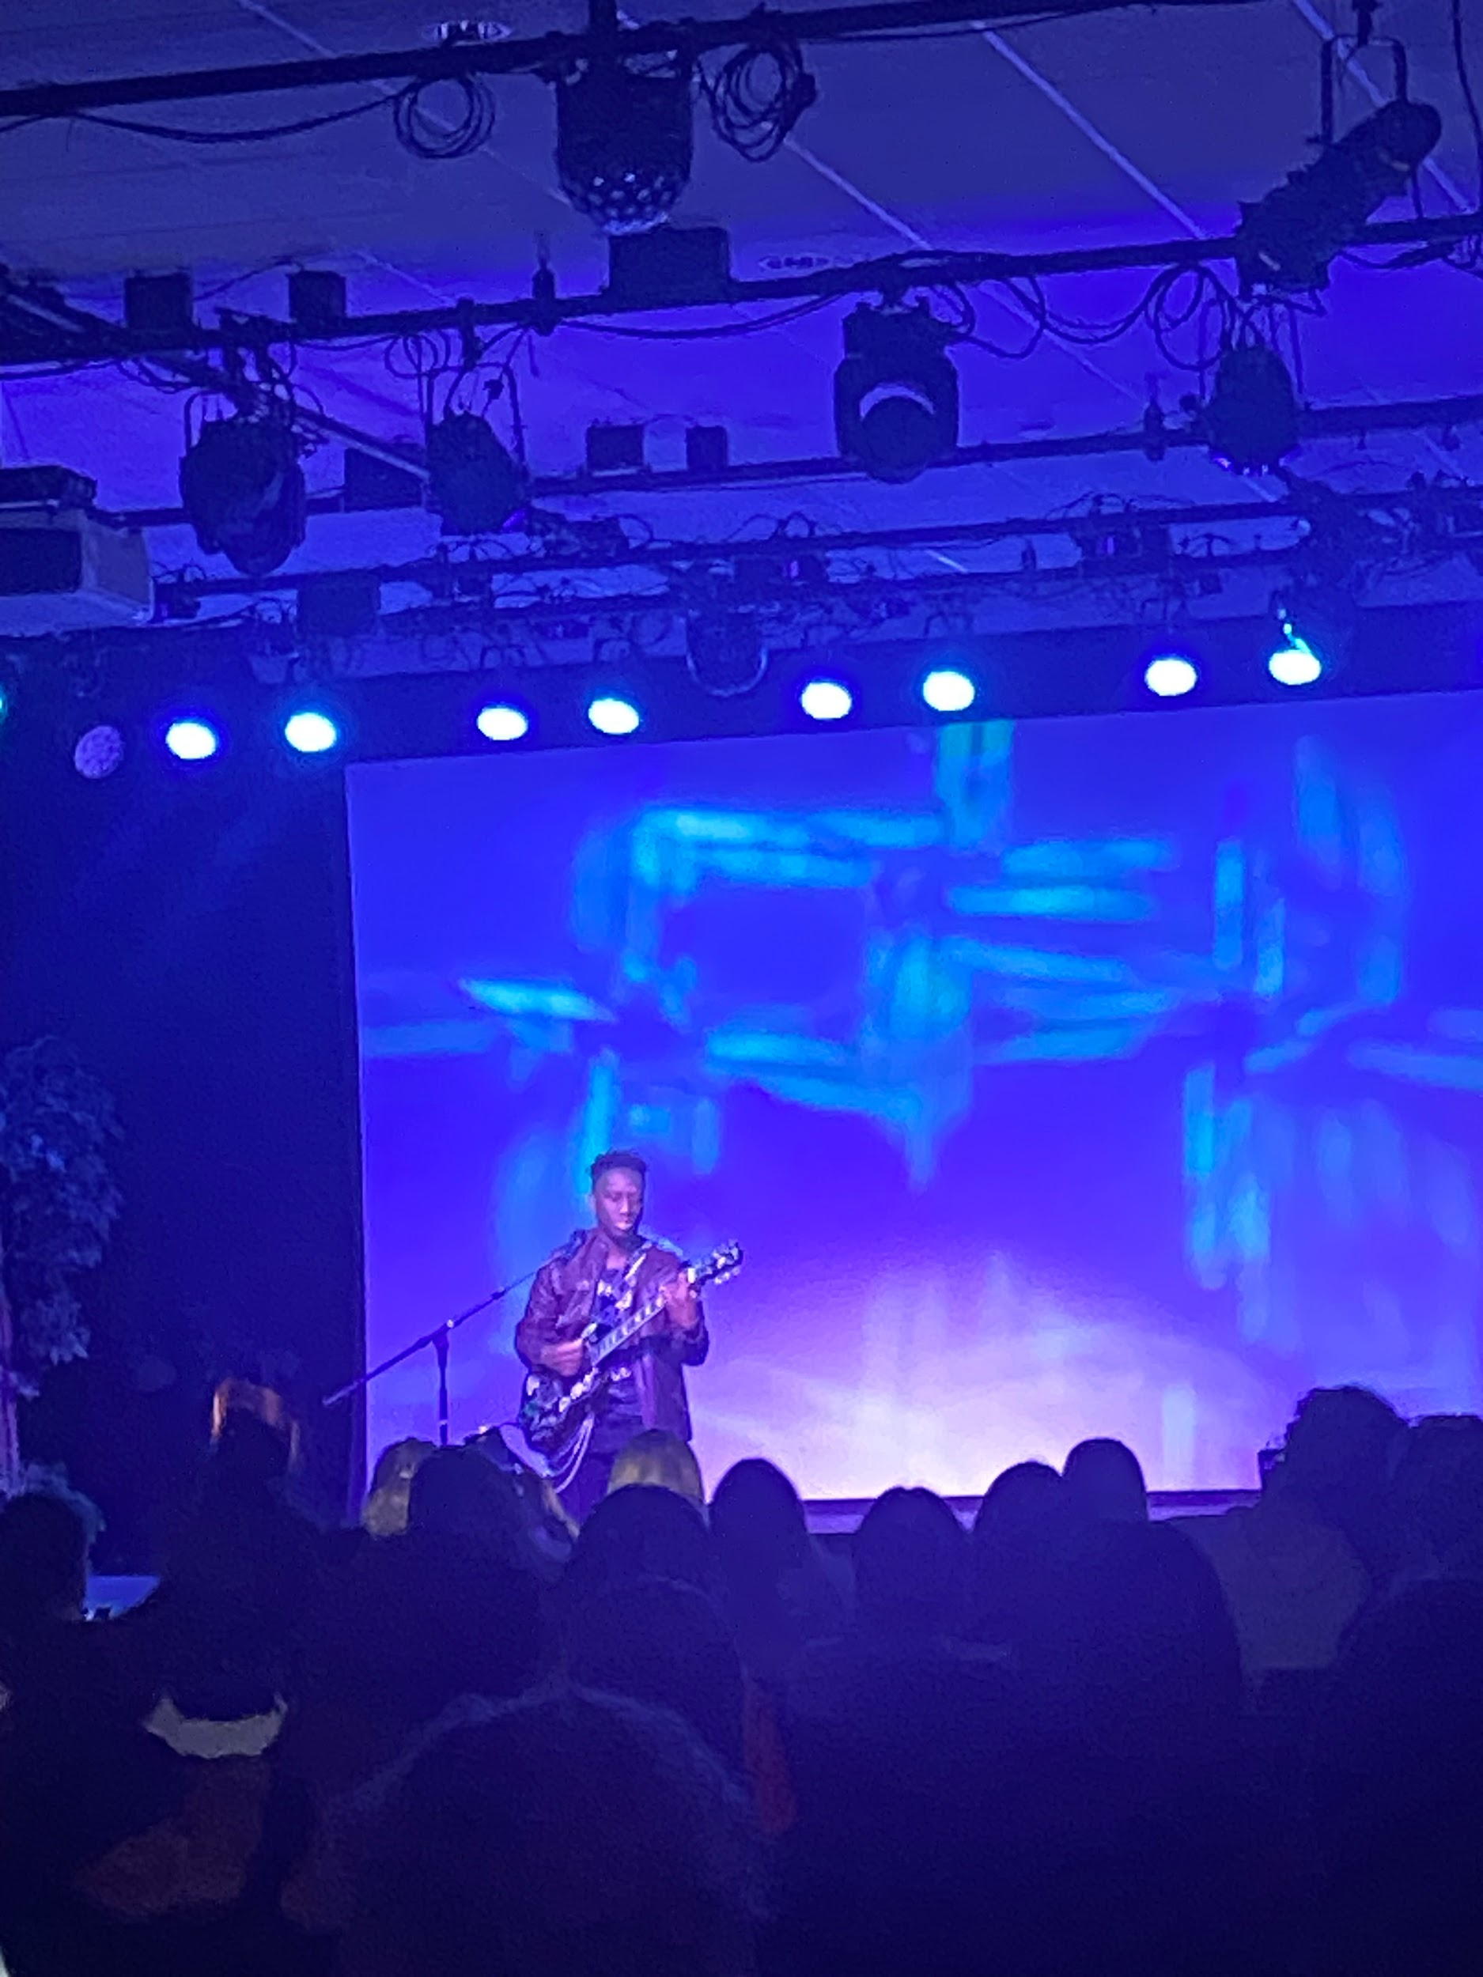

Elizabethtown College’s Sock and Buskin hosts a benefit scholarship concert to honor Jo Russo.

By: Teresa Costa

ELIZABETHTOWN, Pa. - On Sunday, March 24, The Elizabethtown College theater club, Sock and Buskin, presented a benefit scholarship featuring the voices of talented coeds in memory of fellow student Joseph “Jo” Russo. Students said that the performances proved to be a wonderful tribute to Russo’s love of the theater.

In the evening on Monday, February 19, Jo Russo was found unresponsive inside of his dormitory in Founders Hall and had passed away.

Russo was a first year Japanese/English education and secondary education major hoping to pursue a career in education abroad in Japan after graduation. Russo came to Etown after attending high school in Bordentown, New Jersey. He was a young man who used his first college performance “The Language Archive," to not only showcase his talent, but to make new friends on campus. Emily Clark, a fellow theater student, states that the entire department planned this event to honor Russo’s contributions to the thespian community. All the performers said they wanted to honor Russo’s legacy.

Clark was a very close friend of Russo’s. She described him as someone with a very friendly presence.

“He was very kind and loving, honestly like a firework,” Clark said. “Very bright and loud personality, loud soul.”

“You were comfortable the moment you met him,” Clark added. “He would hit you with the same intensity and excitement, making you feel like you were best friends even if you didn’t know each other that well.” There was never a dull moment with Jo whether you liked him or not. His energy was always present on campus.

“Words cannot express how grateful I am to be friends with such great people,” Clark said. “They put effort into all that they do to honor Jo and we were glad for this opportunity and turnout.” The Blue Jay community has come together to honor one of their own.
The whole Etown campus was devastated by the tragic loss of this young student. Sock and Buskin quickly put together a cabaret event that would typically take months of planning and execution. Their hard work and determination attracted many talented students who knew or performed with Russo in the 2023 fall play. Another student, Judas Foster, offered to help by recruiting performers. To their surprise, many students came forward and volunteered to help plan as well as perform to make the night a great success.

In total, $5,577 was raised by the attendees. President Elizabeth Rider also donated $4,500. Sock and Buskin collected enough to create an impact scholarship, which will be given out in increments of $2,500 for the next four years. A donation link was established to keep the scholarship ongoing. Foster stated they found that their biggest job was to help the Office of Institutional Advancement for scholarships.

This was a very emotional experience for Foster. "I am someone who tends to assess the bigger emotions as much as possible,” Foster said. “It can be very overwhelming.”

“Sometimes there was a lump in my throat and burning behind my eyes, but most of the time I felt proud,” Foster added. “This was one of my last events as a Blue Jay and I am so proud of how everyone stepped up in the moment.”

“The tragedy was a whole lot to process, so moving, I was glad to help out in as many ways as possible,” said another student, Julia Yudichak. “It was definitely hard, but I'm glad that I did it.”

“Jo and I were just starting to become friends,” Yudichak added. “The concert was a great way to pay tribute to him and give closure of his loss to the student body.”

This event was a testament as Sock and Buskin came up with a way to make Russo feel honored with the “vibes.” It really felt like a celebration of life more than a memorial. Some of the songs were lighthearted and some were heavy.

All of the performers were wearing red because that was Russo’s favorite color. People were encouraged to wear red and hand out ribbons.

“The memories of Jo will live on in the hearts of his friends just as his spirit was honored by the event,” said student Liz Gatton. “It was really impactful."
“It was a beautiful memorial, a beautiful event,” Gatton added. “It is all reflecting on how I am coping, taking the good that we can away from this tragic situation.”

