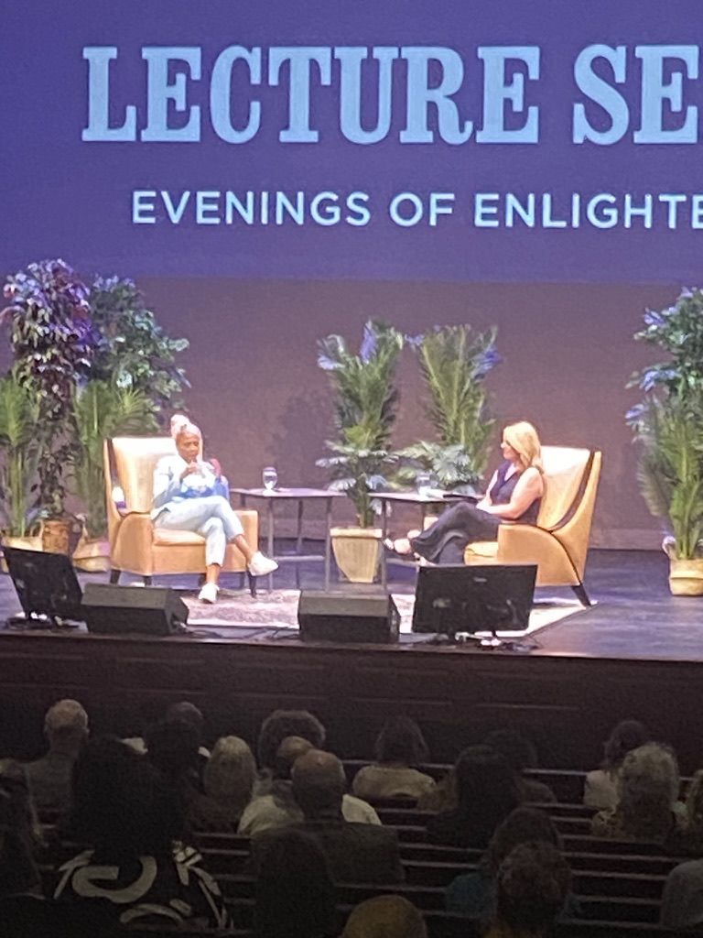

Jemele Hill gives an inspiring lecture to students at Elizabethtown College.

By: Teresa Costa

ELIZABETHTOWN, Pa. - On Thursday evening of April 11, Jemele Hill came to speak to students at Etown to talk about her career and how she found her passion in journalism. Once she discovered journalism, she did not discover anything else and knew that it was her career path.

When Hill was growing up, her mother struggled with addiction, which in turn made Hill’s younger years very challenging. Through her mother’s struggle, she began to absorb herself in following sports teams by reading the newspapers and magazines. Hill’s broad knowledge base by her avid love of sports directed her to pursue a career with an organization where she could use both of her passions, journalism and sports. ESPN gave her that opportunity. ESPN hired her to be a columnist and she has worked for them since 2006. In 2013, she became a permanent cast member of ESPN sports writing.

“In order to be a columnist, you have to do everything in the right place at the right time,” Hill said, “Everyone works together.”

One reason she is grateful for journalism is that it gave her a sense of humanity. Hill believes that we need more people who are willing to say things that have nothing to gain and nothing to lose. A challenge about writing a memoir is that this story can be about people with hope and compassion even when they have hurt you. People have to characterize and depict others who understand commonality. Sports allows us to see issues differently and be on the right side of history when we don’t even know it. The traits in journalism carry over everything.

“When you lead with empathy, you will find humanity and reliability in one another,” Hill said.

“People aren't good or bad,” Hill added. “They are shades of gray.”

“She is very blessed to be able to follow her passion and find her niche,” said student Cassie Teter. “Which amazingly led her into her dream job and a successful career.”

